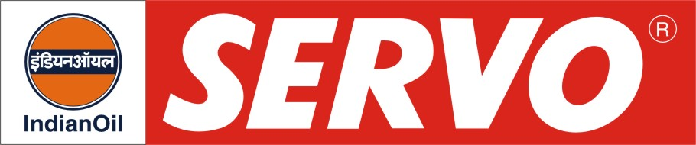
GRADES AVAILABLE Hyundai Servo CRDi Premium Engine oil

DESCRIPTION
Hyundai Servo CRDi Premium Engine oil is a premium diesel engine oil specially designed for Hyundai Diesel cars fitted with CRDi injection system. The oil is designed for the most severe performance requirements of new generation diesel cars retrofitted with features like PCV, EGR, etc. It assures outstanding protection against high temperature engine deposits, oil degradation, oil thickening and corrosion resistance. The oil is having excellent shear stability to maintain viscosity under severe, high temperature operations. It exhibits outstanding control on soot induced oil thickening and soot induced wear.

APPLICATION

Hyundai Servo CRDi Premium Engine oil is recommended for new generation Hyundai Diesel vehicles. It is tailored to the lubrication requirements of engines complying to Euro III. Recommended for use with Diesel fuel, sulphur content upto 0.5% by wt.

PERFORMANCE STANDARDS

* API CH-4 / SL*
* ACEA A3/B3 - 04

PERFORMANCE BENEFITS

# Reduced engine scuffing and bore polishing.
# High engine cleanliness.
# Maximum protection from wear and deposits.
# Improved control of oil consumption.
# Potential for long drain interval.
# Excellent all weather performance due to improved cold weather properties.

CHARACTERISTICS

SAE GRADE | 15W-40
Kinematic Viscosity, cSt @ 100°C | 13.5 – 15.5
Viscosity Index, Min. | 135
TBN, mg KOH/g | 10.0 – 11.5
Flash Point, (COC)°C, Min. | 200
Pour Point °C, Max. | (-) 24

