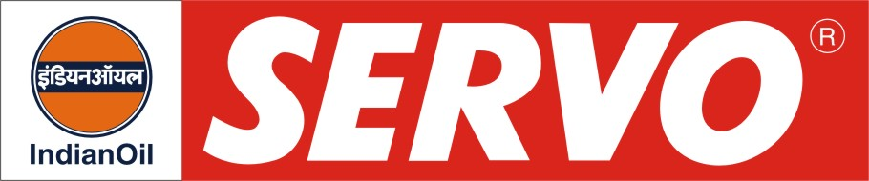
GRADES AVAILABLE – MARUTI GENUINE OIL

DESCRIPTION

Maruti Genuine Oil is high performance engine oil for new generation petrol vehicles. These oils are blended from high viscosity index base stocks and contain additives to meet the stated performance standards. This oil has been extensively evaluated under tough field driving condition.

APPLICATION

Maruti Genuine Oil is recommended for entire Maruti range of petrol vehicles. It is also suitable for other Indian cars.

PERFORMANCE STANDARDS

- API SF in gasoline and CD in diesel service.
- US Military MIL-L-46152 B
- E-PL 2 / E-DL 2 of IS: 13656- 2002.

APPROVAL

- Maruti Udyog Ltd for all petrol vehicles i.e. Maruti 800/ Van / Gypsy/ Esteem/ Wagon R / Zen / Alto / Swift, etc.

PERFORMANCE BENEFITS

- Superior performance in terms of oxidation stability, dispersancy characteristics and energy efficiency.
- Excellent sludge control and extra wear protection at high temperatures and severe operating conditions.
- Outstanding overall engine cleanliness and also provide long engine life.
- Fuel savings and low oil top up.
- Catalytic Convertor Compatible.

CHARACTERISTICS

SAE GRADE | 20W-40
Kin. Viscosity @ 100ºC, cSt | 13.5 – 15.5
Flash Point, COC, ºC, Min | 200
Pour Point, ºC, Max | (-) 21
TBN, mg KOH/gm | 5 - 7

