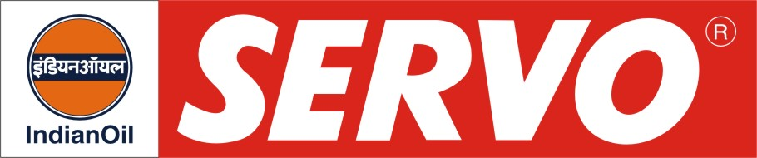

Cement Plant Greases

Product | Colour | Worked Penetration at 25°C after 60 strokes | Drop Point °C, Min | Description / Application
Servogrease 300 | Black | 310 – 340 | 180 | Servogrease 300 is priming and pre-start lubricant recommended for lubrication of freshly installed large open girth gear drives of rotary kilns, cement mills, sintering plants, ball mills, tube mills etc. This grease has adhesive and extreme pressure characteristics to take care of protection from initial damages. Servogrease 300 is applied with a brush.
Servogrease CG 10  Servogrease CG 20  Servogrease CG 50  Servogrease CG 50 (0) | Black  Black  Black  Black | 380 - 420  400 - 430  400 – 430  355 - 385 | 180  180  180  180 | Servogrease CG are sprayable adhesive lubricant, which has been developed for very severe lubrication conditions encountered in very slow speed, large open gear drives. The lubrication films adhere strongly to the gear surface and are unaffected by temperature changes. They are recommended for lubrication of open gear drives in cement plant, steel plant and mining industry such as rotary kilns, cement mills, sintering plants, ball mills etc. They pass FZG 12th stage. Servogrease CG 50(0) is of NLGI zero consistency.
Servogrease RN | Black | 400 – 430 | 180 | Servogrease RN is a running in lubricant recommended during commissioning of large open gear drives of rotary kilns, cement mills, sintering plants, ball mills etc. It passes FZG 12th Stage. It is sprayable also.
Servogrease Repair Compound | Black | 310 – 340 | 180 | Servogrease Repair Compound is recommended for the machining of repaired gear tooth of large open gear drives of rotary kilns, cement mills, sintering plants, ball mills etc. It is applied by a brush, wherever damaged gears are to be repaired. It is approved by M/s. F.L. Smith.

