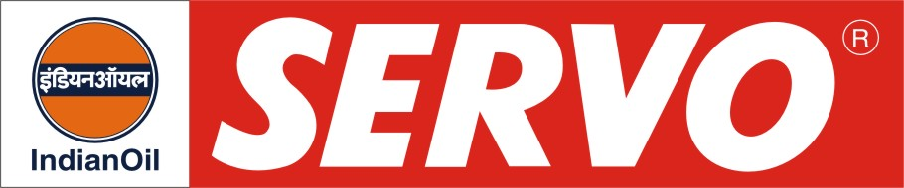

Complex Greases

Product | Colour | Worked Penetration at 25°C after 60 strokes | Drop Point °C, Min | Description / Application
Servorex L0 (M)  Servorex L1 (M)  Servorex L2 (M) | Black  Black  Black | 370 – 400  340 – 385  310 – 340 | 204  204  204 | Servorex greases are calcium-complex base greases for anti-friction and plain bearings operating at medium speed under heavy and/or severe shock loads. Due to their excellent water repellent characteristics these greases are successfully used for bearing lubrication of steel mills, cane crushers and mill rolls of sugar factories. Servorex greases are used by various steel plants in centralised grease lubrication systems and are also recommended for grease lubricated gear couplings.
Servoplex LC 1  Servoplex LC 2  Servoplex LC 3 | Brown  Brown  Brown | 290 – 315  280 – 305  220 – 250 | 260  260  260 | Servoplex LC are lithium complex greases having high water tolerance and mechanical stability combined with excellent high temperature performance. Servoplex LC is ideally suited for application by centralised grease systems due to good resistance to oil separation under pressure and mechanical stability. Servoplex LC greases are widely in use in Steel Plants, Mining and Engineering Industries.
Servoplex GC 1-1000 | Black | 310 – 340 | 180 | Servoplex GC 1-1000 is a lithium complex; NLGI 1 grease formulated with highly viscous base oil and is specially designed for lubrication of couplings of various designs. It provides effective lubrication and protection against wear in heavily loaded gear couplings and resists separation of the oil from the soap thickener at high rotating speeds.
Servogem Super HT 0  Servogem Super HT 1  Servogem Super HT  Servogem Super HT (T)  Servogem Super HT (B)  Servogem Super HTXX | Brown  Brown  Brown  Brown  Brown  Black | 355 – 385  310 – 340  265 – 295  275 – 295  265 – 280  265 - 295 | 280  303+  303+ 280  280  300 | Servogem Super HT and Super HTXX are premium quality modified calcium sulphonate complex greases suitable for lubrication over a wide temperature range of (-)100C to + 1800C and has excellent pumpability characteristics making it specially suitable for centralised lubrication systems of large industrial units. Servogem Super HT Greases are recommended for wide range of industrial applications where high temperatures are encountered. Servogem Super HTXX is incorporated with solid lubricants for superior performance under conditions of high load, high temperature & ingress of water. These greases are ideal choice for Steel Plant applications such as continuous casters, couplings, oscillators, run out rolls, blowers, furnace doors etc. They are also suitable for Mining Industries for applications such as rock crushers, conveyor, drilling machinery etc.
Servoplex AL 00  Servoplex AL 2 | Brown  Light Brown | 400 – 430  265 – 295 | 160  260 | Servoplex AL greases are premium quality Aluminium-complex grease which provide excellent performance in anti-friction bearings and increased lubrication life compared to lime, sodium and lithium greases. Servoplex AL 2 is recommended for application areas such as steel plants, mining, textile etc. where conditions of high load, temperature and ingress of water exists. Servoplex AL 00 is suitable for gear lubrication. The products are available with base oils of different ISO VG grease.
Servogem TX  Servogem TXX  Servogem TXX EP | Brown  Black  Black | 265 – 295  265 – 295  265 - 295 | 260  260  260 | Servogem TX, TXX and TXX EP are Titanium – Lithium Complex greases possessing inherent high load carrying capacity, enhanced oxidation stability, anti-rust and anti-corrosion properties. They are recommended for high temperature applications in steel plants, power plants, paper and packaging industry etc. Servogem TXX contains solid lubricant and takes care of severe lubrication requirements of high temperature, heavy load conditions. These greases are compatible with Lithium, Lithium Complex, Aluminium Complex, Clay based greases etc.

