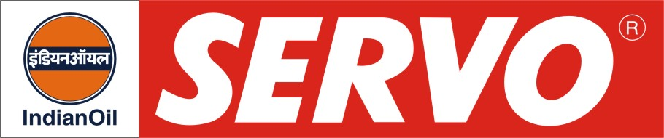

General Equipment & Machinery Greases

Product | Colour | Worked Penetration at 25°C after 60 strokes | Drop Point °C, Min. | Description / Application
Servogem 2  Servogem 3 | Light Brown  Light Brown | 265 – 295  220 – 250 | 180  180 | Servogem 2 and 3 are multipurpose greases recommended for anti-friction and plain bearings lubrication. Servogem 2 and 3 meet the requirement of British Timken ALG bearing 1/57, IS: 7623-1993 (Second Revision) Reaffirmed 2001, IPSS:1-09-006-1997 specifications and U.S. Steel 374 requirement. These greases are widely used in steel plants, heavy engineering units, textile mills, petrochemical and chemical units etc.
Servogem EP 00  Servogem EP 0  Servogem EP 0 (N)  Servogem EP 1  Servogem EP 2  Servogem EP 2 ( C )  Servogem EP 2 (S) | Brown  Brown  Dark Brown  Brown  Dark Brown Brown  Dark brown | 400 – 430  355 – 385  355 – 385  310 – 340  265 – 295  280 – 300  265 - 280 | 170  180  190  180  180  100  180 | Servogem EP greases possess extreme pressure (EP) properties and prevent welding and seizure of moving parts often caused by shock loading. Servogem EP greases meet IPSS: 1-09-005-1999 and IS:: 7623-1993 (Second Revision) Reaffirmed 2001, specification. These greases are recommended for both plain and anti-friction bearings in a wide variety of applications such as automotive, earth moving equipments, gear couplings, electric motors, mining equipments and general industrial machinery. Servogem EP 2 (C) grease is a lime base grease developed to meet the IPSS 1-09-009-1997 requirements. The product is suitable for lubrication of severely loaded bearings at a temperature of (-) 20 to +650C where ingress of water cannot be avoided. Servogem EP 0(N) has better water washout resistance and higher antiwear properties. Servogem EP 2(S) has superior thermal and oxidation stability and resistance to water washout.

