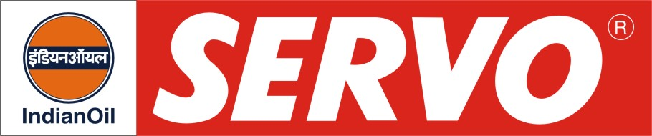
Synthetic Hydraulic Oils

PRODUCT | Kin. Viscosity cSt at 40 °C | VI Min. | Flash Point COC, °C Min. | Description / Application
Servosystem SHC 32  Servosystem SHC 46  Servosystem SHC 68  Servosystem SHC 100 | 29 – 35  42 – 50  62 – 74  90 - 110 | 135  135  135  140 | 230  230  230  230 | Servosystem SHC Oils are formulated from synthetic hydrocarbon base fluids and selected additive system. They can be effectively used in severe duty operations under high loads and extreme temperature conditions such as cold start up or very high operating temperatures. They are recommended for high and low pressure gear, vain and piston stationery and mobile hydraulic systems.
Servosystem BD S 46  Servosystem BD S 68 | 42 – 50  58 - 70 | 190  180 | 270  270 | Servosystem BD S Oils are anti wear type, synthetic bio-degradable hydraulic oils for applications where contamination due to leakage or blown hydraulic lines present an environmental hazard. They fall under CETOP HEES hydraulic fluid and typically provide a bio-degradability value of more than 80% as per CEC L 33 A 94 test.

