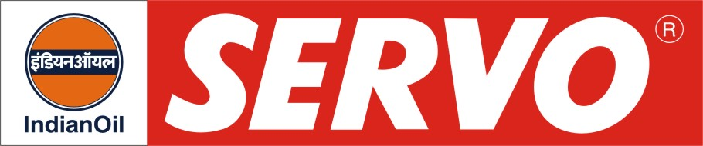

Water Resistant Grease

Product | Colour | Worked Penetration at 25°C after 60 strokes | Drop Point °C, Min | Description / Application
Servogrease WR 1(B)  Servogrease WR 2  Servogrease WR 2 (460)  Servogrease WR 2(B) | Black  Black  Brown  Black | 295 - 315  275 – 295  280 – 300  275 - 295 | 190  175  175  175 | Servogrease WR Greases are smooth structured grease based on Lithium - Calcium mixed soap specially designed to meet the lubrication requirement of areas where excessive water ingress cannot be avoided. They possess excellent water resistance, EP, anti-rust and anti-wear properties for meeting the severe lubrication requirements in steel mill and other applications. They are suitable for centralized lubrication system. Servogrease WR2 (460) is formulated with base oil viscosity of ISO VG 460.  Servogrease WR 1(B) and WR 2(B) have superior EP characteristics.
Wire Rope Greases  Servogrease WRL 00  Servogrease WRL 2 | Black  Black | 400 – 430  265 – 295 | 180  250 | Servogrease WRL greases are Aluminium Complex Grease with good adhesive, extreme pressure and anti-wear characteristics. They are specially developed for lubrication of wire ropes in draglines, cranes, shovels, elevators, drilling rigs etc. They protect wire ropes from rust and corrosion and increase their life.
Servogem SI 0 | Black | 370 – 400 | 220 | Servogrease SI 0 is a semi fluid grease containing solid lubricants and extreme pressure additives for lubrication of large open gear drives working under heavy load, low speed and high ambient temperature conditions in sponge iron industry, construction, mining, rotary kilns, Sugar mills etc. It can be used through dip as well as sprayable system.

