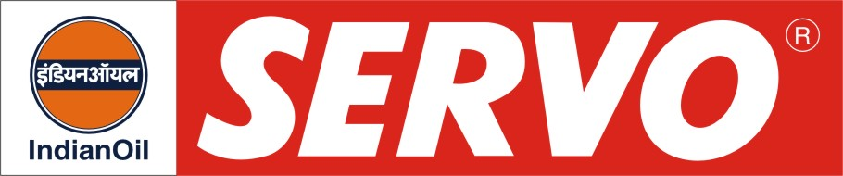
GRADES AVAILABLE – SERVO EICHER ENGINE OIL
DESCRIPTION

Servo Eicher Engine Oil is high performance diesel engine oil, which provides excellent protection against corrosive wear in all types of diesel engines. This oil is suitable for all seasons and retains high level of alkalinity during use.

APPLICATION

Servo Eicher Engine Oil is recommended for:

- Highly supercharged diesel engines
- Commercial service in diesel engines
- Off highway equipments
- Stationary DG Sets

PERFORMANCE STANDARDS

Servo Eicher Engine Oil meets the following specifications.

- API CF / CD
- E-DL 3 of IS: 13656-2002
- US Military MIL-L-2104C
- MACK T7
- Sequence III F

MANUFACTURERS APPROVAL
Servo Eicher Engine oil is approved M/s Eicher Motors as Genuine Oil.

PERFORMANCE BENEFITS

Servo Eicher Engine Oil provides:
- Improved cold starting and faster engine warm up.
- Outstanding engine cleanliness even under most severe operating conditions.
- Exceptional thermal and oxidation stability to resist decomposition in super charged engines operating with high ring zone temperatures.
- Longer battery life.
- Lower fuel and engine oil consumption.
- Excellent resistance to wear.

CHARACTERISTICS

SAE GRADE | Servo Eicher Engine Oil
Kinematic Viscosity cSt @ 100°C | 13.5 – 15.5
Viscosity Index, Min. | 110
Flash point (COC), °C Min. | 200
Pour Point, °C Max. | (-) 21
TBN mg KOH/gm | 9.5 – 12.5

