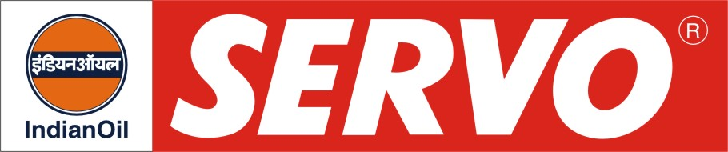
GRADES AVAILABLE - SERVO RR 407, 606 MG, 501 MG, 520 MG
DESCRIPTION
Servo RR oils have been developed to meet lubrication requirements of various makes of rail road diesel engines currently in operation with the Indian Railways. These oils are blended using high quality base stocks having excellent thermal and oxidation stability. Special additives incorporated in these oils impart high degree of detergency, dispersancy coupled with the desired level of alkalinity to combat the ill effects of combustion products of high sulphur fuels.

APPLICATION
Servo RR 407 is “Extra Performance” zinc free Generation IV Oil and is recommended for GM, EMD and ALCO Locomotives.

Servo RR 606 MG is Generation IV Plus Multi grade oil and is recommended for ALCO Locomotives.

Servo RR 501 MG and 520 MG are Generation V zinc free MG oils and are recommended for ALCO and GE & GM, EMD Locos.

PERFORMANCE STANDARDS

Servo RR 407 meets the following specification:

- General Motors Corporation, USA requirements of MI-1761C
- U.S. Military MIL-L-45199B

PERFORMANCE BENEFITS

Servo RR oils
- Provide extended service life of rings and cylinder liners
- Give adequate protection to turbocharger bearings
- Keep engine parts clean
- Possess high alkalinity which helps to combat corrosive effect of sulphur present in the fuel

CHARACTERISTICS

 | RR 407 | RR 606 MG | RR 501 MG | RR 520 MG
SAE GRADE | 40 | 20W-40 | 20W-40 | 20W-40
Kinematic Viscosity cSt @ 100°C | 15.5 – 16.3 | 15.5 – 16.3 | 15.5 – 16.3 | 15.5-16.3
Viscosity Index, Min. | 90 | 110 | 110 | 110
Flash point (COC), °C Min. | 225 | 200 | 200 | 200
Pour Point, °C Max. | (-) 6 | (-) 21 | (-) 21 | (-)21
TBN, mg. KOH/g (Typical) | 13 | 17 | 13 | 17

