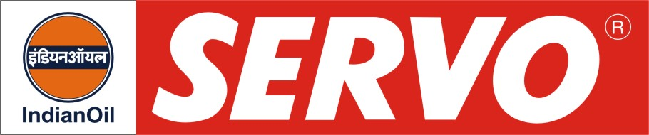
GRADES AVAILABLE - SERVO PRIDE ALT 15W-40
DESCRIPTION

Servo Pride ALT 15W-40 is premium commercial diesel engine oil. The oil is designed for the most severe performance requirements of new generation diesel engines for on and off highway operations. It assures outstanding protection against high temperature engine deposits, oil degradation, oil thickening and corrosion resistance. The oil is having excellent shear stability to maintain viscosity under severe, high temperature operations. It exhibits outstanding control on soot induced thickening and soot induced wear.

APPLICATION

Servo Pride ALT 15W-40 is recommended for new generation commercial diesel vehicles of Ashok Leyland complying to Bharat Stage II & III Emission Norms. It is especially compounded for use with diesel fuel ranging in sulphur content upto 0.5% by wt.

PERFORMANCE STANDARDS

* API CH-4
* MB 228.5

APPROVAL

- Ashok Leyland Ltd, Chennai.

PERFORMANCE BENEFITS
# Reduced engine scuffing and bore polishing.
# High engine cleanliness.
# Maximum protection from wear and deposits.
# Suitable for mixed fleet operation.
# Improved control of oil consumption.
# Easier cold starting.
# Excellent all weather performance due to improved cold weather properties.
# Has the potential to doubled the oil drain
intervals compared to current diesel engine
oils.
compared to current diesel engine oils
period.

CHARACTERISTICS

SAE GRADE | ALT 15W-40
Kinematic Viscosity, cSt @ 100°C | 13.5 – 15.5
Viscosity Index, Min. | 135
TBN, mg KOH/g | 10.0 – 11.5
Flash Point, (COC)°C, Min. | 200
Pour Point °C, Max. | (-) 24

